Chris Klassen – Melvin Loho – Jonathan Chu – Joel Mabbott

BCIT  3700 Willingdon Avenue

Windows assignment 3 TESTING document

Table of Contents

Overview 2

Test Cases 2

Figures 3

Figure 1 (Website No Server) 3

Figure 2 (Website No Clients) 3

Figure 3 (Website Multiple Clients) 4

Figure 4 (Server Multiple Clients) 4

Figure 5 (Client WiFi) 5

Figure 6 (Client 3G) 5

Figure 7 (Client No Server) 6

# Overview

# Test Cases

|  |  |  |  |  |
| --- | --- | --- | --- | --- |
| Test Number | Test | Tool / Application | Expected Outcome | Pass/Fail |
| 1 | Website running with no server | Application | Website runs normally but receives no new data | Pass |
| 2 | Website running with no clients | Application | Website runs normally but displays no clients on the map or table | Pass |
| 3 | Website running with multiple clients | Application | Website runs normally, displaying multiple clients | Pass |
| 4 | Server receiving data from multiple clients | Application | Server updates xml file with new clients | Pass |
| 5 | Client sending to server over WiFi | Application | Server receives data from client | Pass |
| 6 | Client sending to server over 3G | Application | Server receives data from client | Pass |
| 7 | Client sending to no server | Application | Client runs normally but data does not get received | Pass |

# Figures

## Figure 1 (Website No Server)

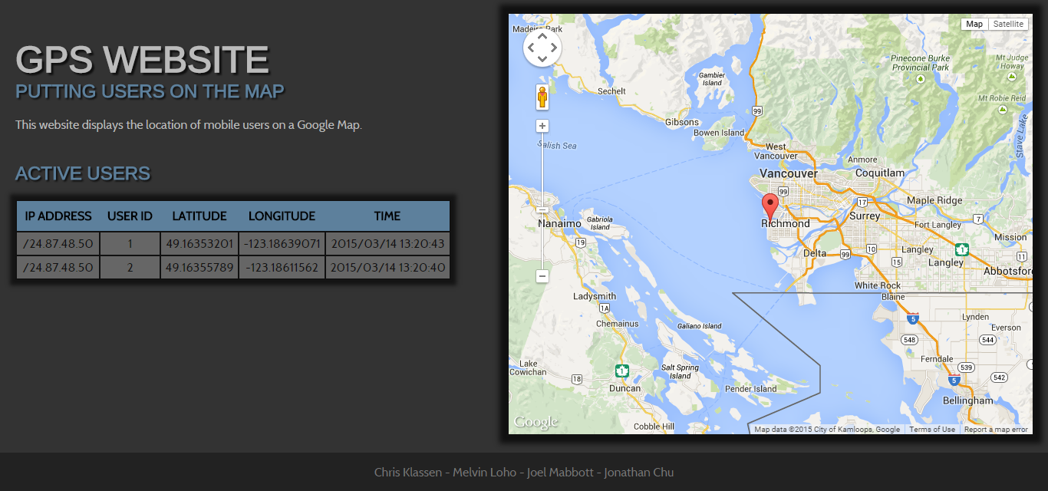

## Figure 2 (Website No Clients)

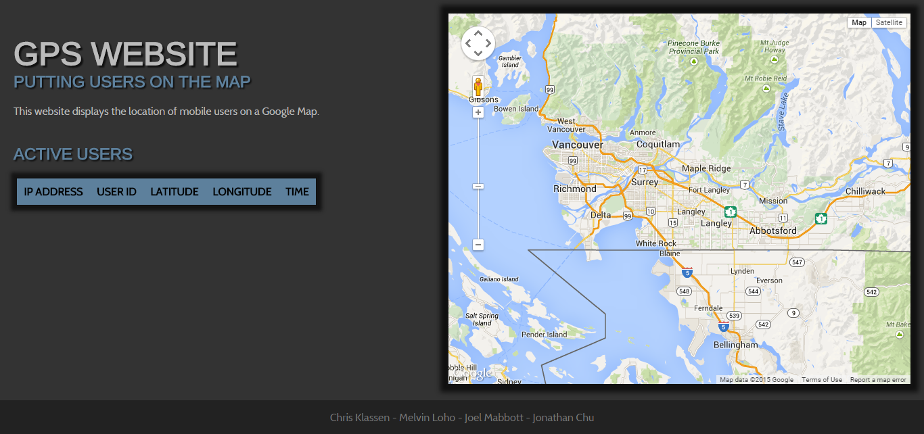

## Figure 3 (Website Multiple Clients)

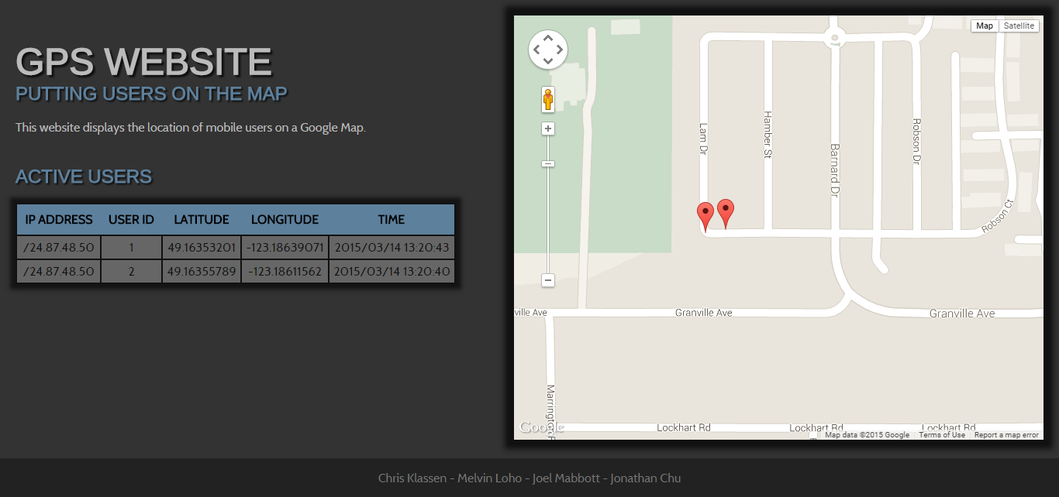

## Figure 4 (Server Multiple Clients)

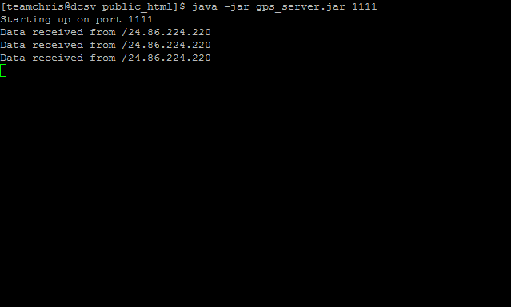

## Figure 5 (Client WiFi)

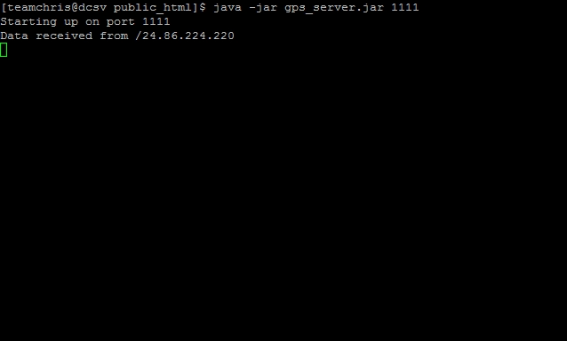

## Figure 6 (Client 3G)

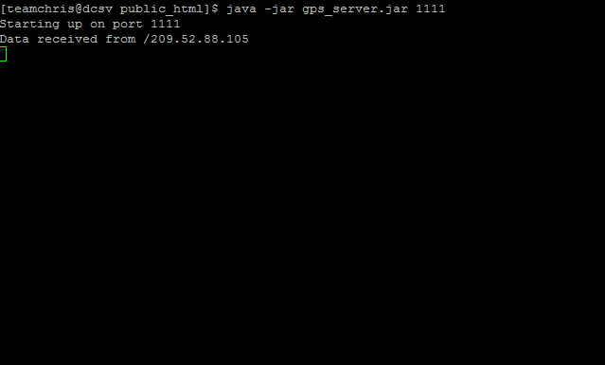

## Figure 7 (Client No Server)

